Chapter 8

Input/Output Organization

- Serial and Parallel Communication Interfaces
- Programmed I/O
- Interrupt, types of interrupts, Interrupt processing, Interrupt hardware and priority
- Direct Memory Access, I/O Processors

Serial and Parallel communication Interfaces
Parallel Communication
In data transmission, parallel communication is a method of conveying multiple binary digits (bits) simultaneously. Parallel transmission of data is used for short distance where the speed of information transfer is critical. This form of data communication is found in newer type of computer peripheral equipment with transfer speed of to one million characters per second. The equipment includes printers, disk drives and various other forms of peripheral components.
If the device operates at different speeds, then microprocessor can be used to select a particular speed of operation of the device. The techniques used to transfer data between different speed devices and computer is called synchronizing. There are various ways of synchronization techniques which are involved in parallel data transfer such as simple input and output, simple strobe I/O, single handshaking and double handshaking.
Simple I/O
To get digital data from a simple switch into a microprocessor; switch is connected on input port line from which port can be read. The data is always present and ready so that it can be read at any time. Similarly to output data to a simple display device like LED, the input of LED buffer is connected on an output port pin. And output the logic level required turning on the light. The LED is always there and ready so that data can be sent at any time.
Simple Strobe I/O
In many applications, valid data is present on an external device only at a certain time and must be read in at that time. Here a strobe pulse is supplied to indicate the time at which data is being transmitted. For an example, we can discuss the ASCII encoded keyboard. When a key is pressed, circuitry on keyboard sends out ASCII code for pressed key on eight parallel data lines and then sends out a strobe signal on another line to indicate that valid data is present on eight data lines.
Single Handshaking
Handshaking is the method of synchronizing the actions of slow peripheral devices with that of high speed microprocessor. It can have two transfer schemes.
- Input Handshake (Peripheral to Microprocessor)
- The peripheral outputs some data and send $\overline{STB}$ signal to microprocessor to tell “Here is the data for you”.
- Microprocessor detects asserted $\overline{STB}$ signal, reads the data and sends an acknowledge signal (ACK) to indicate data has been read and peripheral can send next data, “I got that one, send me another”.
- Microprocessor sends or receives data when peripheral is ready.
- Output Handshake (Peripheral from Microprocessor)
Microprocessor outputs data to peripheral and asserts a strobe ($\overline{STB}$) signal. If peripheral is ready it answers back with acknowledgement ($ACK$) signal to microprocessor.
Double Handshaking
For data transfers where even more coordination is required between the sending system and the receiving system, a double handshake is used. It can have two transfer schemes.
- Input Handshake (Peripheral to Microprocessor)
- The peripheral asserts its $\overline{STB}$ line low to ask microprocessor “Are you ready?”
- The microprocessor raises its $ACK$ line high to say “I am ready”.
- Peripheral then sends data and raises its $\overline{STB}$ line low to say “Here is some valid data for you.”
- Microprocessor then reads the data and drops its ACK line to say, “I have the data, thank you, and I await your request to send the next byte of data.”
- Output Handshake(Peripheral from Microprocessor)
Microprocessor sends a strobe ($\overline{STB}$) signal and data and peripheral sends acknowledgement ($ACK$) signal.

Serial Communication
In data transmission, serial communication is the process of sending data one bit at a time, sequentially, over a communication channel or computer bus. Within a microcomputer data is transferred in parallel, because that is the fastest way to do it. For transferring data over long distances, however, parallel data transmission requires too many wires. Therefore, data to be sent long distances is usually converted from parallel form to serial form so that it can be sent on a single wire or pair of wires. Serial data received from a distant source is converted to parallel form so that it can easily be transferred on the microcomputer buses.
- Serial Synchronous Data Transmission
In serial synchronous data transmission, data is transmitted or received based on a clock signal. At a specific rate of data transmission, the transmitting device sends a data bit at each clock pulse. In order to interpret the data correctly, the receiving device must know the start and end of each data unit. The transmitter must know the number of data units to be transferred and the receiver must be synchronized with the data boundaries. Therefore, there must be synchronization between the transmitter and receiver. Usually one or more SYNC characters are used to indicate the start of each synchronous data stream or frame of data. Transmitter sends a large block of data characters one after the other with no time between characters. Transmitting device sends data continuously to the receiving device. If the data is not ready to be transmitted, the line is held in marking condition. To indicate the start of transmission, the transmitter sends out one or more SYNC characters or a unique bit pattern called a flag, depending on the system being used. The receiving device waits for data, when it finds the SYNC characters or the flag then starts interpreting the data which shifts the data following the SYNC characters and converts them to parallel form so they can be read in by a computer.

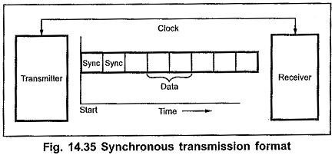
Fig: Synchronous Serial Transmission Format

- Serial Asynchronous Data Transmission
The receiving device does not need to be synchronized with the transmitting device. The transmitting device can send one or more data units when it is ready to send data. Each data unit must be formatted i.e. must contain start and stop bits for indicating beginning and the end of data unit. It also includes one parity bit to identify odd or even parity of data. To send ASCII character, the framing of data should contain:
- 1 start bit: Beginning of data
- 8 bit character: Actual data transferred
- 1 or 2 stop bits: End of data
When no data is being sent, the signal line is in a constant high or marking state. The beginning of the data character is indicated by the line going low for 1 bit time and this bit is called a start bit. The data bits are then sent out on the line one after the other where the least significant bit is sent out first. Parity bit should contain to check for errors in received data. After the data bit and a parity bit, the signal line is returned high for at least 1 bit time to identify the end of the character, this always high bit is referred to as a stop bit. Some older systems use 2 stop bits.
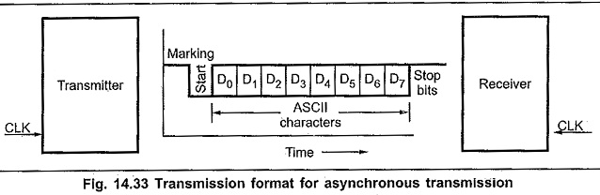
Fig: Serial Asynchronous Data Transmission

Characteristics of Serial Communication:
- Baud rate is used to measure the speed of transmission. It is described as the number of bits passing in one second. For example, if the baud rate is 200 then 200 bits per Sec passed. In telephone lines, the baud rates will be 14400, 28800 and 33600.
- Stop Bits are used for a single packet to stop the transmission which is denoted as “T”. Some typical values are 1, 1.5 & 2 bits.
- Parity Bit is the simplest form of checking the errors. There are of four kinds, i.e., even odd, marked and spaced. For example, If 011 is a number the parity bit=0, i.e., even parity and the parity=1, i.e., odd parity.

Programmed I/O
- Programmed I/O operations are the result of I/O instructions written in the computer program.
- In programmed I/O, each data transfer in initiated by the instructions in the CPU and hence the CPU is in the continuous monitoring of the interface.
- Input instruction is used to transfer data from I/O device to CPU, store instruction is used to transfer data from CPU to memory and output instruction is used to transfer data from CPU to I/O device.
- This technique is generally used in very slow speed computer and is not a efficient method if the speed of the CPU and I/O is different.
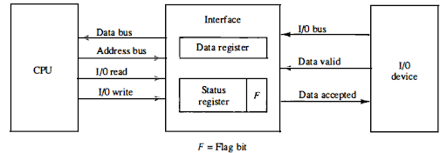
Fig: Data transfer from I/O device to CPU
- I/O device places the data on the I/O bus and enables its data valid signal
- The interface accepts the data in the data register and sets the F bit of status register and also enables the data accepted signal.
- Data valid line is disables by I/O device.
- CPU is in a continuous monitoring of the interface in which it checks the F bit of the status register.
  - If it is set i.e. 1, then the CPU reads the data from data register and sets F bit to zero
  - If it is reset i.e. 0, then the CPU remains monitoring the interface.
- Interface disables the data accepted signal and the system goes to initial state where next item of data is placed on the data bus.
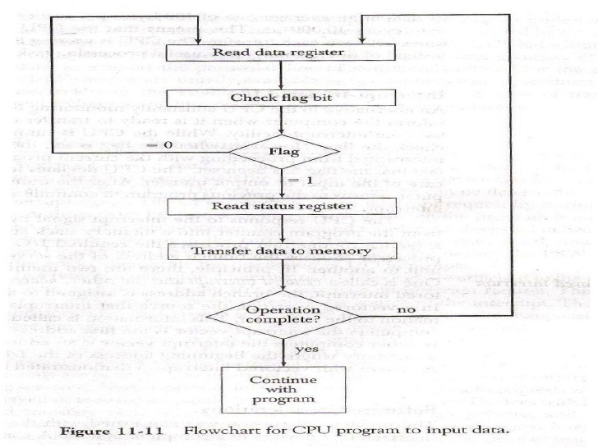
Fig: flowchart for CPU program to input data
Characteristics:
- Continuous CPU involvement
- CPU slowed down to I/O speed
- Simple
- Least hardware

Polling, or polled operation, in computer science, refers to actively sampling the status of an external device by a client program as a synchronous activity. Polling is most often used in terms of input/output (I/O), and is also referred to as polled I/O or software driven I/O.

Interrupt-driven I/O
- Polling takes valuable CPU time
- Open communication only when some data has to be passed -> Interrupt.
- I/O interface, instead of the CPU, monitors the I/O device
- When the interface determines that the I/O device is ready for data transfer, it generates an Interrupt Request to the CPU
- Upon detecting an interrupt, CPU stops momentarily the task it is doing, branches to the service routine to process the data transfer, and then returns to the task it was performing

The problem with programmed I/O is that the processor has to wait a long time for the I/O module of concern to be ready for either reception or transmission of data. The processor, while waiting, must repeatedly interrogate the status of the I/O module. As a result, the level of the performance of the entire system is severely degraded. An alternative is for the processor to issue an I/O command to a module and then go on to do some other useful work. The I/O module will then interrupt the processor to request service when it is ready to exchange data with processor. The processor then executes the data transfer, and then resumes its former processing. The interrupt can be initiated either by software or by hardware.

Interrupt Driven I/O basic operation
- CPU issues read command
- I/O module gets data from peripheral whilst CPU does other work
- I/O module interrupts CPU
- CPU requests data
- I/O module transfers data

Interrupt Processing from CPU viewpoint
- Issue read command
- Do other work
- Check for interrupt at end of each instruction cycle
- If interrupted:-
  - Save context (registers)
  - Process interrupt
  - Fetch data & store
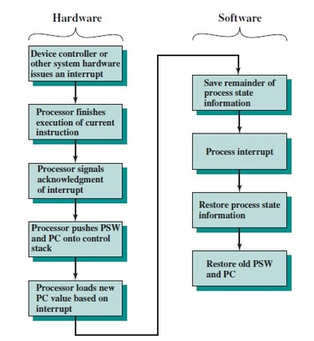
Fig: Simple Interrupt Processing

Priority Interrupt
- Determines which interrupt is to be served first when two or more requests are made simultaneously
- Also determines which interrupts are permitted to interrupt the computer while another is being serviced
- Higher priority interrupts can make requests while servicing a lower priority interrupt

Priority Interrupt by Software (Polling)
- Priority is established by the order of polling the devices (interrupt sources), that is identify the highest-priority source by software means
- One common branch address is used for all interrupts
- Program polls the interrupt sources in sequence
- The highest-priority source is tested first
- Flexible since it is established by software
- Low cost since it needs a very little hardware
- Very slow

Priority Interrupt by Hardware
- Require a priority interrupt manager which accepts all the interrupt requests to determine the highest priority request
- Fast since identification of the highest priority interrupt request is identified by the hardware
- Fast since each interrupt source has its own interrupt vector to access directly to its own service routine

- Daisy Chain Priority (Serial)


- Interrupt Request from any device
- CPU responds by INTACK
- Any device receives signal(INTACK) at PI puts the VAD on the bus
- Among interrupt requesting devices the only device which is physically closest to CPU gets INTACK and it blocks INTACK to propagate to the next device
WORKING:
There is an interrupt request line which is common to all the devices and goes into the CPU.
- When no interrupts are pending, the line is in HIGH state. But if any of the devices raises an interrupt, it places the interrupt request line in the LOW state.
- The CPU acknowledges this interrupt request from the line and then enables the interrupt acknowledge line in response to the request.
- This signal is received at the PI(Priority in) input of device 1.
- If the device has not requested the interrupt, it passes this signal to the next device through its PO(priority out) output. (PI = 1 & PO = 1)
- However, if the device had requested the interrupt, (PI =1 & PO = 0)
  - The device consumes the acknowledge signal and block its further use by placing 0 at its PO(priority out) output.
  - The device then proceeds to place its interrupt vector address(VAD) into the data bus of CPU.
  - The device puts its interrupt request signal in HIGH state to indicate its interrupt has been taken care of.
NOTE: VAD is the address of the service routine which services that device.
- If a device gets 0 at its PI input, it generates 0 at the PO output to tell other devices that acknowledge signal has been blocked. (PI = 0 & PO = 0)
Hence, the device having PI = 1 and PO = 0 is the highest priority device that is requesting an interrupt. Therefore, by daisy chain arrangement we have ensured that the highest priority interrupt gets serviced first and have established a hierarchy. The farther a device is from the first device, the lower its priority.
- Parallel Priority
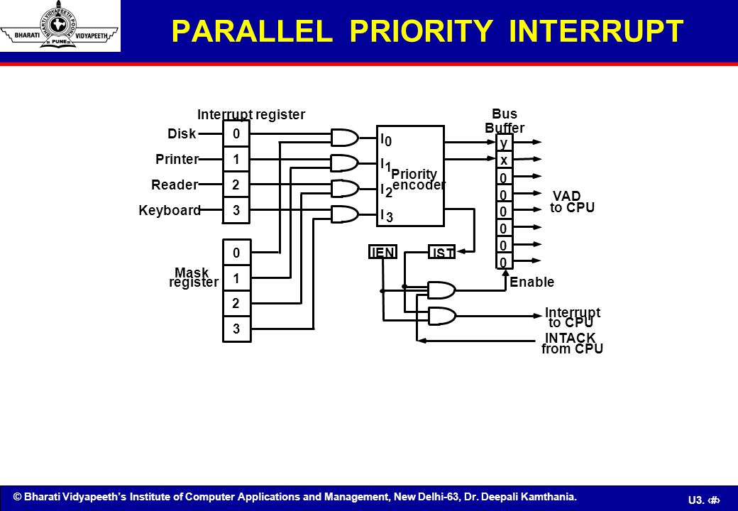
Fig: Parallel priority interrupts hardware

- IEN: Set or Clear by instructions ION or IOF
- IST: Represents an unmasked interrupt has occurred. INTACK enables tristate Bus Buffer to load VAD generated by the Priority Logic
- Interrupt Register:
  - Each bit is associated with an Interrupt Request from different Interrupt Source - different priority level
  - Each bit can be cleared by a program instruction
- Mask Register:
  - Mask Register is associated with Interrupt Register
  - Each bit can be set or cleared by an Instruction

Direct Memory access
- Large blocks of data transferred at a high speed to or from high speed devices, magnetic drums, disks, tapes, etc.
- DMA controller Interface that provides I/O transfer of data directly to and from the memory and the I/O device
- CPU initializes the DMA controller by sending a memory address and the number of words to be transferred
- Actual transfer of data is done directly between the device and memory through DMA controller -> Freeing CPU for other tasks

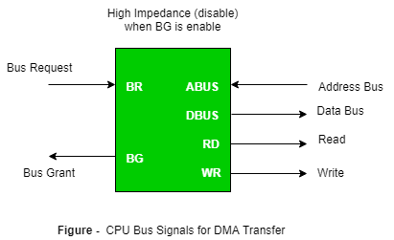
The transfer of data between the peripheral and memory without the interaction of CPU and letting the peripheral device manage the memory bus directly is termed as Direct Memory Access (DMA).

The two control signals Bus Request and Bus Grant are used to fascinate the DMA transfer. The bus request input is used by the DMA controller to request the CPU for the control of the buses. When BR signal is high, the CPU terminates the execution of the current instructions and then places the address, data, read and write lines to the high impedance state and sends the bus grant signal. The DMA controller now takes the control of the buses and transfers the data directly between memory and I/O without processor interaction. When the transfer is completed, the bus request signal is made low by DMA. In response to which CPU disables the bus grant and again CPU takes the control of address, data, read and write lines.
The transfer of data between the memory and I/O of course facilitates in two ways which are DMA Burst and Cycle Stealing.
DMA Burst: The block of data consisting a number of memory words is transferred at a time.
Cycle Stealing: DMA transfers one data word at a time after which it must return control of the buses to the CPU.
- CPU is usually much faster than I/O (DMA), thus CPU uses the most of the memory cycles
- DMA Controller steals the memory cycles from CPU
- For those stolen cycles, CPU remains idle
- For those slow CPU, DMA Controller may steal most of the memory cycles which may cause CPU remain idle long time

DMA Controller
The DMA controller communicates with the CPU through the data bus and control lines. DMA select signal is used for selecting the controller, the register select is for selecting the register. When the bus grant signal is zero, the CPU communicates through the data bus to read or write into the DMA register. When bus grant is one, the DMA controller takes the control of buses and transfers the data between the memory and I/O.
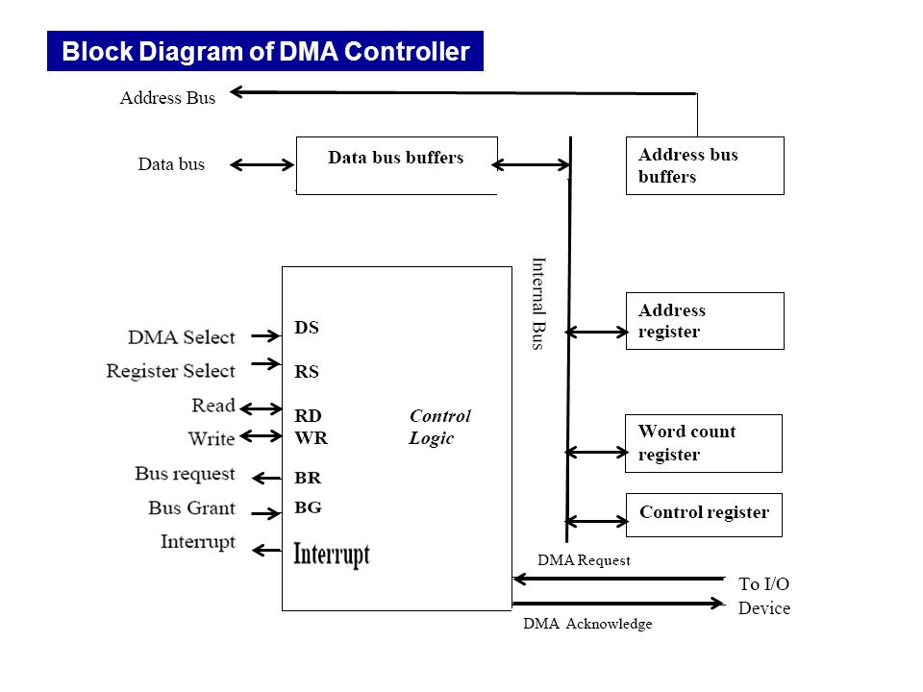
Fig: Block diagram of DMA controller
The address register specifies the desired location of the memory which is incremented after each word is transferred to the memory. The word count register holds the number of words to be transferred which is decremented after each transfer until it is zero. When it is zero, it indicates the end of transfer. After which the bus grant signal from CPU is made low and CPU returns to its normal operation. The control register specifies the mode of transfer which is Read or Write.
DMA Transfer
- DMA request signal is given from I/O device to DMA controller.
- DMA sends the bus request signal to CPU in response to which CPU disables its current instructions and initialize the DMA by sending the following information.
  - The starting address of the memory block where the data are available (for read) and where data to be stored (for write)
  - The word count which is the number of words in the memory block
  - Control to specify the mode of transfer
  - Sends a bust grant as 1 so that DMA controller can take the control of the buses
  - DMA sends the DMA acknowledge signal in response to which peripheral device puts the words in the data bus (for write) or receives a word from the data bus (for read).
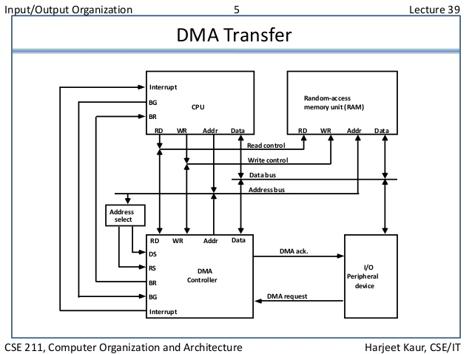
Fig: DMA transfer in a computer system
DMA Operation
- CPU tells DMA controller:-
  - Read/Write
  - Device address
  - Starting address of memory block for data
  - Amount of data to be transferred
- CPU carries on with other work
- DMA controller deals with transfer
- DMA controller sends interrupt when finished

I/O Processors
- Processor with direct memory access capability that communicates with I/O devices
- Channel accesses memory by cycle stealing
- Channel can execute a Channel Program
- Stored in the main memory
- Consists of Channel Command Word(CCW)
- Each CCW specifies the parameters needed by the channel to control the I/O devices and perform data transfer operations
- CPU initiates the channel by executing a channel I/O class instruction and once initiated, channel operates independently of the CPU
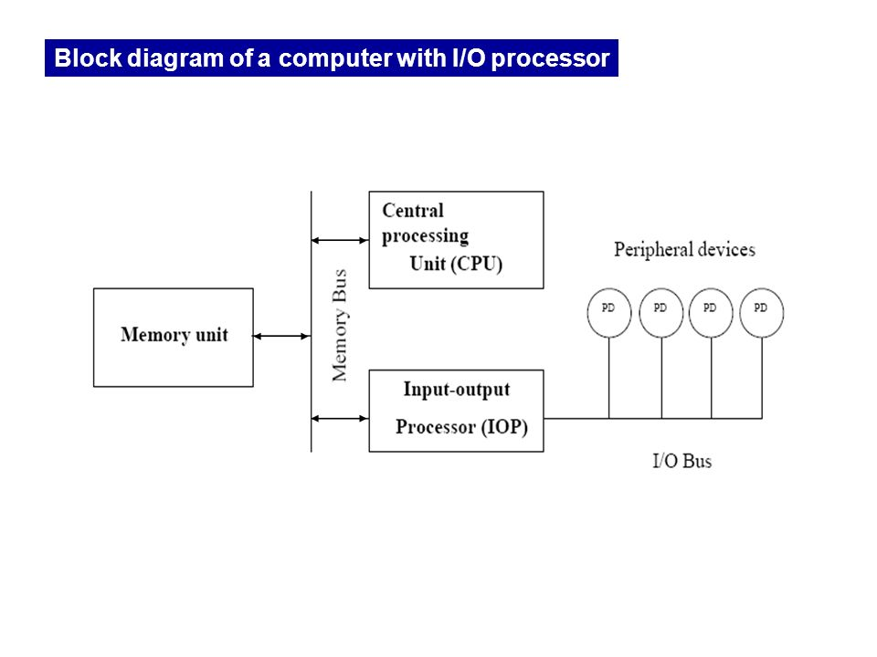
A computer may incorporate one or more external processors and assign them the task of communicating directly with the I/O devices so that no each interface need to communicate with the CPU. An I/O processor (IOP) is a processor with direct memory access capability that communicates with I/O devices. IOP instructions are specifically designed to facilitate I/O transfer. The IOP can perform other processing tasks such as arithmetic logic, branching and code translation.

Fig: Block diagram of a computer with I/O Processor

The memory unit occupies a central position and can communicate with each processor by means of direct memory access. The CPU is responsible for processing data needed in the solution of computational tasks. The IOP provides a path for transferring data between various peripheral devices and memory unit.
In most computer systems, the CPU is the master while the IOP is a slave processor. The CPU initiates the IOP and after which the IOP operates independent of CPU and transfer data between the peripheral and memory. For example, the IOP receives 5 bytes from an input device at the device rate and bit capacity. After which the IOP packs them into one block of 40 bits and transfer them to memory. Similarly the O/P word transfer from memory to IOP is directed from the IOP to the O/P device at the device rate and bit capacity.

CPU – IOP Communication
The memory unit acts as a message center where each processor leaves information for the other. The operation of typical IOP is appreciated with the example by which the CPU and IOP communication.

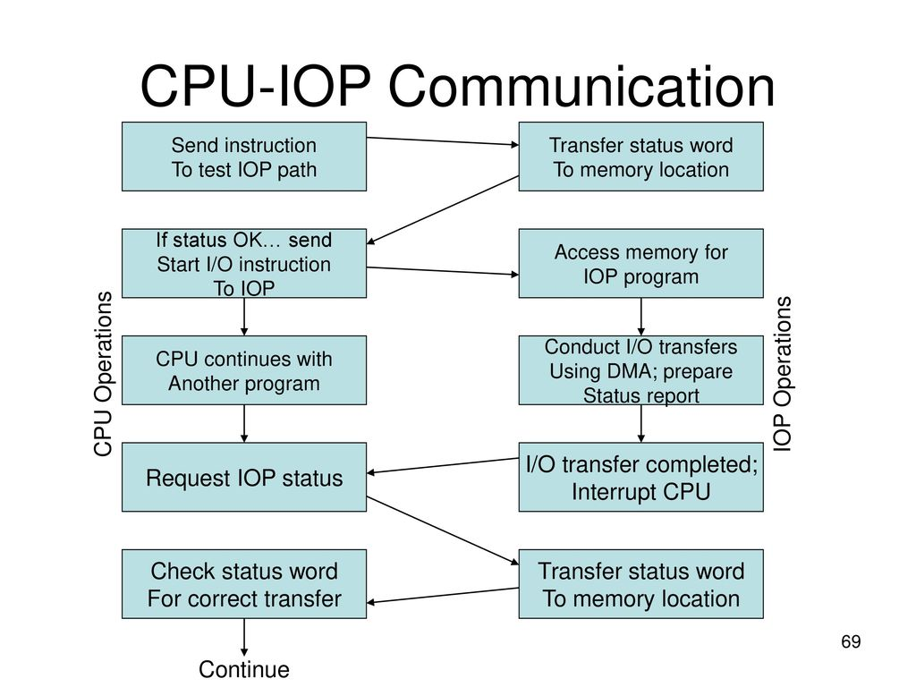
Fig: CPU-IOP communication

The CPU sends an instruction to test the IOP path.
- The IOP responds by inserting a status word in memory for the CPU to check.
- The bits of the status word indicate the condition of the IOP and I/O device, such as IOP overload condition, device busy with another transfer or device ready for I/O transfer.
- The CPU refers to the status word in in memory to decide what to do next.
- If all right up to this, the CPU sends the instruction to start I/O transfer.
- The CPU now continues with another program while IOP is busy with I/O program.
- When IOP terminates the execution, it sends an interrupt request to CPU.
- CPU responds by issuing an instruction to read the status from the IOP.
- IOP responds by placing the contents to its status report into specified memory location.
- Status word indicates whether the transfer has been completed or with error.

